Student Name: Fozhan

Student ID: 029701865

I certify that this submission is my original work

Fozhan Babaeiyan Ghamsari

**Project Report: Programming Project 1 - “Energy released by earthquakes”**

**The last two pages include the code and the output.**

1. **Goal:** For each Richter scale measurements, the program will calculate and output the amount of energy in Joules and tones of TNT exploded. Then it will ask the user to input a float value for richter and print the amount of energy in Joules and tons.
2. **Problem Description:** There are five Important Richter values given which for each we need to calculate energy and tons and we need to assign the numbers to our variable richter. After this we will ask the user to input a value for richter and print all of our calculations as aligned in the output of our desired output. Energy in Joules can be measured as follows: 10^((1.5*richterValue) +4.8) and tons: energy / (4.184* (10^9))
3. **Program Description:** A brief description of your program and how your program works that includes the followings:

**Inputs:**

Richter_user => a float value asking for richter

**Process:**

Energy in joules would be calculated from the input given by the user

Energy = 10^ ((1.5* Richter_user) +4.8)

TNT in tons will be calculated from energy

Tons = energy / (4.184 *(10^9))

Calculating the energy and tons for each value of richter

Richter=1

Richter=5

Richter=9.1

Richter=9.2

Richter=9.5

Printing the descriptions and then outputting the values calculated.

**Outputs:**

Richter Joules TNT

1 1995262.3149688789 0.00047687913837688307

5 1995262314968.8828 476.87913837688404

9.1 2.818382931264449e+18 673609687.2046962

9.2 3.981071705534953e+18 951498973.5982201

9.5 1.1220184543019653e+19 2681688466.3048882

Please enter a Richter scale value: 3.4

Richter scale value: 3.4

Equivalence in joules: 7943282347.242789

Equivalence in tons of TNT: 1.8984900447521007

**Pseudo Code**

1. Start
2. Define Richter Scale Measurements/ richter =1.0
3. energy in joules=10**((1.5*richter)+4.8)
4. Energy in tons of exploded TNT = energy in joules / 4.184 * 10**9
5. Print “Richter”
6. Print “Joules “
7. Print “TNT”
8. Consider the spacing for them
9. amount of energy in Joules for richter=1.0
10. find the equivalent amount of energy in tons for richter=1.0
11. print the values richter, joules and tnt respectively for richter =1.0
12. amount of energy in Joules for richter=5.0
13. find the equivalent amount of energy in tons for richter=5.0
14. print the values richter, joules and tnt respectively for richter =5.0
15. amount of energy in Joules for richter=9.1
16. find the equivalent amount of energy in tons for richter=9.1
17. print the values richter, joules and tnt respectively for richter =9.1
18. amount of energy in Joules for richter=9.2
19. find the equivalent amount of energy in tons for richter=9.2
20. print the values richter, joules and tnt respectively for richter =9.2
21. amount of energy in Joules for richter=9.5
22. find the equivalent amount of energy in tons for richter=9.5
23. print the values richter, joules and tnt respectively for richter =9.5
24. align TNT values by the decimal point.
25. print an empty space
26. ask user for a float value, float(input())
27. assign the given number by user to richter_user
28. print richter scale value, richter_user
29. print equivalence in joules, energy
30. print equivalence in tons of TNT: , tons
31. end

**flowchart**

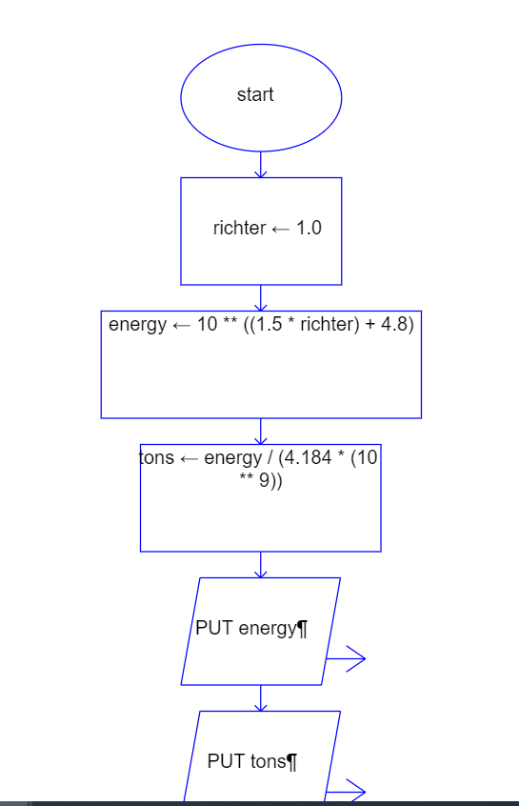

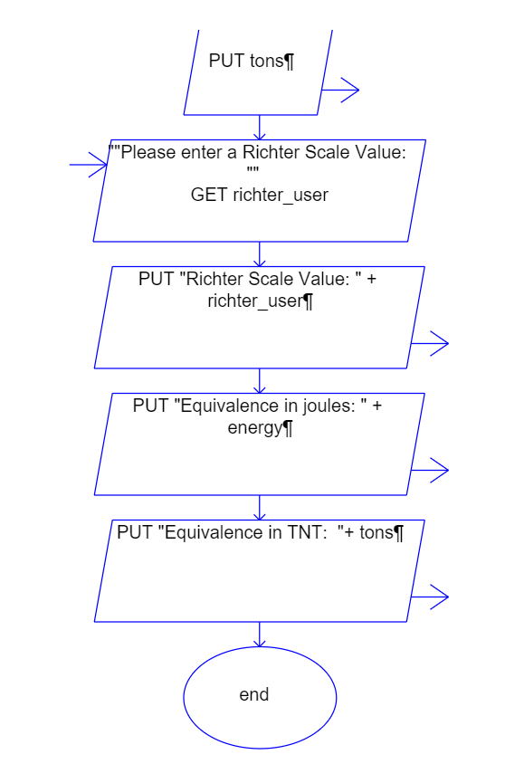

1. **Program Implementation:** Describe the implementation
   * 1. data types: float, integers, strings, list,
     2. operations: 10**((1.5*richter) + 4.8), energy/(4.184* (10**9)),
     3. built-in functions: print(), input(), float()
   1. Formatting alignment of the output was the most challenging for me, which i got help from the website.
   2. Asking for input and printing out the string and the variables calculated was straightforward.
   3. Negative numbers and strings to check the output are counted as bad inputs.
   4. For negative input it will calculate a number which is a logical error and if the input is a string, it will lead to a runtime error.
   5. Bugs and/or Errors:
      1. Calculating the energy for negative richter and runtime error for a string given as the input of the richter.
2. **Conclusion:** Lessons Learned:
   1. What went well in this project? Assigning variables and figuring out the operations.
   2. What you would do differently given another opportunity (about writing a code, about your study skills, and time management)? I would try to start earlier with the coding process and not be afraid of sketching the flowchart.
   3. What are the improvements that might have made the project better or clearer? Please be specific. Adding comments made my code more organized and easier to read. Assigning variables to each value helped me not to get confused.
   4. What are the improvements that the instructors and TAs might have done to promote learning? Please be specific. Asking us to draw the flowchart and the pseudo code helped me get a better understanding of what I should do. Providing a great link which I used for formatting my string output really helped me how to write a cleaner and better code and understand how printing an output clearly is very important.

**Appendix:**

**#Project 1 source code**

#start of the program

'''This program evaluates energy in joules and TNT in tons by given richter'''

#printing Richter, Joules and TNT as in a table formatting with string alignment

#calculating energy and tons for 5 values of 1, 5, 9.1, 9.2, 9.5

richter1 = 1

energy1 = 10**((1.5*richter1)+4.8)

tons1 = energy1/(4.184 * 10**9)

richter5 = 5

energy5 = 10**((1.5*richter5)+4.8)

tons5 = energy5/(4.184 * 10**9)

richter9_1 = 9.1

energy9_1 = 10**((1.5*richter9_1)+4.8)

tons9_1 = energy9_1/(4.184 * 10**9)

richter9_2 = 9.2

energy9_2 = 10**((1.5*richter9_2)+4.8)

tons9_2 = energy9_2/(4.184 * 10**9)

richter9_5 = 9.5

energy9_5 = 10**((1.5*richter9_5)+4.8)

tons9_5 = energy9_5/(4.184 * 10**9)

#putting the variables in a way to print them out

Richter = [

    ['Richter', 'Joules', 'TNT'],

    [richter1, energy1, tons1],

    [richter5, energy5, tons5],

    [richter9_1, energy9_1, tons9_1],

    [richter9_2, energy9_2, tons9_2],

    [richter9_5, energy9_5, tons9_5]

]

#https://scientificallysound.org/2016/10/17/python-print3/

#used this website to help with the alignments

print('{:<14} {:>7} {:>23} '. format(Richter[0][0], Richter[0][1], Richter[0][2]))

print('{:<10} {:>4} {:>36} '. format(Richter[1][0], Richter[1][1], Richter[1][2]))

print('{:<10} {:>4} {:>30} '. format(Richter[2][0], Richter[2][1], Richter[2][2]))

print('{:<10} {:>4} {:>20} '. format(Richter[3][0], Richter[3][1], Richter[3][2]))

print('{:<10} {:>4} {:>20} '. format(Richter[4][0], Richter[4][1], Richter[4][2]))

print('{:<10} {:>4} {:>19} '. format(Richter[5][0], Richter[5][1], Richter[5][2]))

print()

#ask user for a float richter value

#evaluate the energy and tons and print the values as asked

richter_user = float(input('Please enter a Richter scale value: '))

energy = 10**((1.5*richter_user)+4.8)

tons = energy/(4.184 * 10**9)

print('Richter scale value: ', richter_user)

print('Equivalence in joules: ', energy)

print('Equivalence in tons of TNT: ', tons)

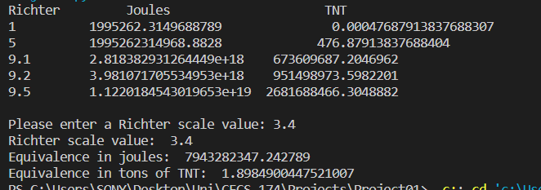**#Project 1 Output**